Ballistic Calculations

A few assumptions & definitions …

* x-axis (x) is along the long axis of the field
* y-axis (y) is along the horizontal axis of the field
* z-axis (z) is vertical
* shooting height (h) = height from turret to center of target
  + We are going to assume that the turret height is 0 along the z-axis
  + We are going to assume that h is fixed.
* range (R) = total length of trajectory from turret through the zenith and back down to the height of the turret
* distance (d) = distance from turret to center of target (straight path)
  + We are assuming the camera will give us this distance
* dH = distance from turret to wall directly below the target along the horizontal axis of the turret
* θ = angle between the horizontal axis at the height of the turret to the target
* α = angle on the x/y plane between the turret and the target. If the robot is not moving α would be 0.0 (i.e. the turret points at the target), positive means the turret shoots to the right side of the target, and a negative angle means the turret shoots to the left of the target.
* All measurements in feet, seconds, and degrees
* For a ballistic trajectory the motion along the horizontal axis and vertical axis are completely independent. Thus, the horizontal component and vertical component can be separated by simply taking the cos or sin of the angle of the initial trajectory.
* v0 = Initial velocity of ball
* vH = initial velocity along the horizontal vector towards the target in the x/y plane
* v0H = velocity along the horizontal vector towards the target in the x/y plane velocity which will not change through the flight unless acted upon by air resistance or spinning
* v0z = initial velocity along the vertical axis
* Vz = velocity along the vertical axis. Changes over time due to gravity
* g = gravity = 32.2 ft/sec2

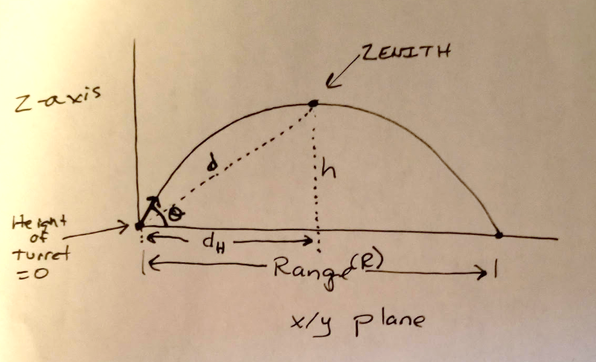

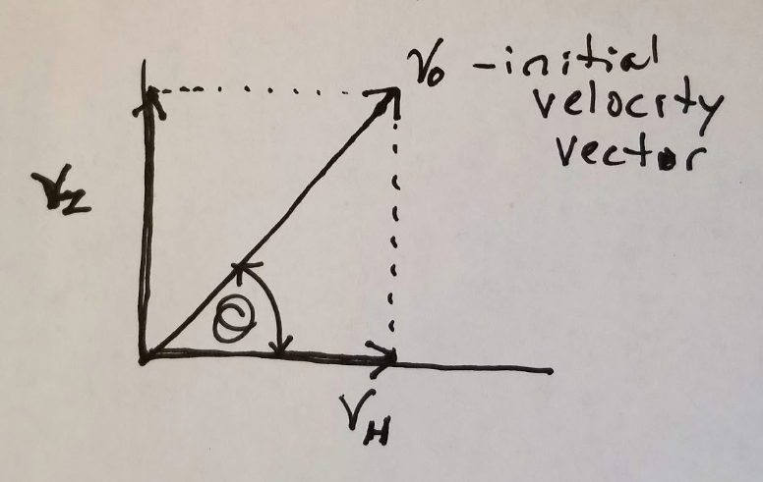

Initial velocity can be broken into a vertical component and a horizontal component

$v_{0H}=v_{0}cos(∅)$ (1)

$v_{0z}=v_{0}sin(∅)$ (2)

Without air resistance and effects from spinning the acceleration on the H axis is 0 and along the z-axis is g

$v_{H}=v_{0}cos(∅)$ (3)

$v_{z}=v_{0}sin\left(∅\right)-gt$ (4)

Let’s start by performing calculations assuming the robot is not moving and both the turret angle and the wheel speed (initial velocity) are variable and that we will hit the target at the zenith.

We will add some #s for the example. We will assume the distance to target (d) is 30’ and h = 7’

Given the distance from the turret to the center of the target and knowing the height of the target we can determine the horizontal distance from the turret to the wall directly below the target from a simple Pythagorean theorem calculation.

$d_{H}=\sqrt{d^{2}-h^{2}}$ (5)

$d_{H}=\sqrt{{30}^{2}-7^{2}}=29.17'$ (6)

There is a relationship between the horizontal range (H) and the maximum height of the trajectory (h).

$∅=arctan⁡\left(\frac{4h}{2d_{H}}\right)$ (7)

$∅=\arctan\left(\frac{4\left(7\right)}{2\left(29.17\right)}\right)={25.64}^{°}$ (8)

We can also determine the velocity needed to hit the maximum height given an angle

$v_{0}=\sqrt{\frac{d_{H}^{2}g}{d_{H}sin2∅-2hcos^{2}∅}}$ (9)

$v_{0}=\sqrt{\frac{{\left(29.17\right)}^{2}(32.2)}{\left[29.17 sin \left(2\left(25.64\right)\right)\right]-[2\left(29.17\right)cos^{2}\left(25.64\right)]}}$ = 49.06 ft/sec (10)

Thus, for a given distance from turret to center of target of 30’ the launch angle is 26.64° with a velocity of 49.06 ft/sec. Only a2+b2=c2 and two equations for the angle and velocity are needed, both with a unique answers, assuming we are hitting the target at the zenith.

Now let’s assume that the robot is still not moving, but that the velocity of the turret is fixed. This may be easier to mechanically pull-off rather than continuously changing the wheel speed velocity as the robot changes it distance to the target. The downside to this is that the ball is not always hitting the target at the zenith and hence will have a smaller offset while still be able to hit the target.

Given a fixed initial velocity of the target as well as dH and h being fixed, the angle to the target can be calculated with:

$∅=arctan\left(\frac{v_{0 }^{2}± \sqrt{v_{0}^{4}-g(gd_{H}^{2}+2hv_{0}^{2})}}{gd_{H}}\right)$ (11)